**QUESTION:** There are many ways to graph data. Make a claim about whether a line graph is better than a circle graph for representing motion data. Use evidence to support your claim.

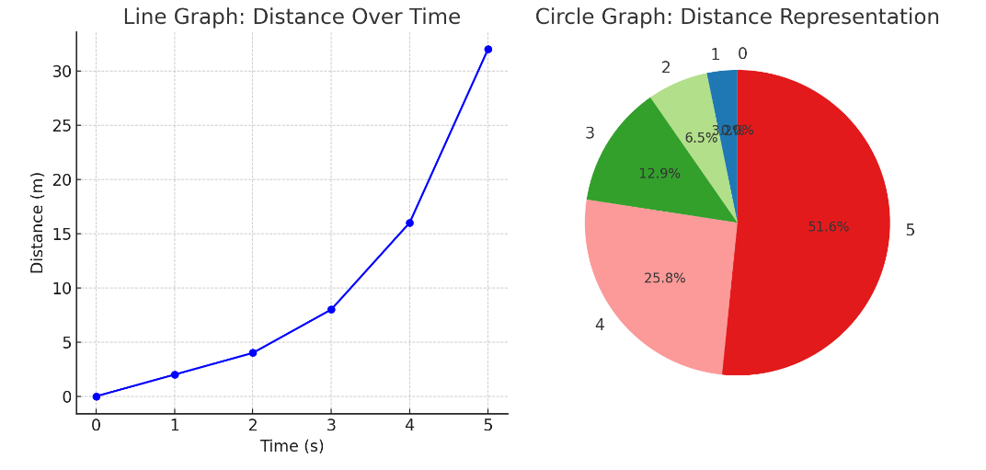**Answer:**

***Circle graph example:***

***Attempts to represent the same motion data but doesn't provide clear information about how distance changes over time.***

***line graph example:***

***Tracks distance over time.***

***Shows how the distance changes as time progresses.***

**Circle Graph**: This pie chart attempts to show the same motion data, but it doesn't convey the change over time effectively. Instead, it just shows how the total distance is divided into parts, which isn’t useful for analyzing motion.

**Line Graph**: This graph shows how distance changes over time. You can clearly see the increasing trend in the distance as time progresses, making it useful for representing motion data.